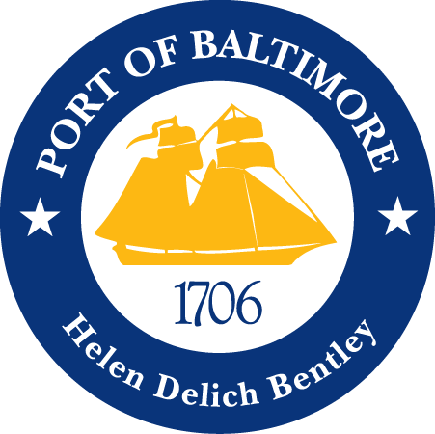

2018 AAPA COMMUNICATION AWARDS SUBMISSION
Port of Baltimore
A True GreenPort
Classification 1: Advertisements
Port Category: 2
Summary:
Ports are associated with shipping, commerce and high emissions. The Maryland Port Administration (MPA) is working to offset environmental impacts from port operations with green projects that meet stewardship goals and provide community benefits. We have a wonderful GreenPort of Baltimore initiative which focuses on rebuilding eroded islands through dredged sediment, repopulating the Chesapeake Bay ecosystem by planting native wetland grasses and installing floating wetlands, and by administering programs on the marine terminals such as the Clean Diesel program and constructing proper storm water management systems. The “A True GreenPort” advertisement was created to promote the successes that the Port of Baltimore has had, in partnership with our communities, in restoring the Chesapeake Bay ecosystem.
1. What are/ were the entry’s specific communications challenges or opportunities?
The Port of Baltimore was founded in 1706 as a port of entry for the tobacco trade with England. Over the last 300 years, the Port has been a wonderful economic engine for our state but has not always been the best environmental steward. Though green efforts have been produced by the Port for many years, dredging can be traced back to 1783, but our GreenPort of Baltimore program was established in 2010. Since this program has started, the Chesapeake Bay health report card has seen constant upward trends since 2011. This is not only due to the GreenPort of Baltimore’s efforts, but to the community awareness and involvement.
In recent years, the Port has strengthened our green tactics; bringing in community members to help plant native wetland grasses and install floating wetlands to encourage the ecosystem’s natural balance. In addition to this, the Maryland Port Administration (MPA) has established relationships with the Maryland Department of the Environment (MDE) and Waterfront Partnership to support community environmental education programs. These efforts have established a quickly recovering ecosystem for local marine life and water fowl. Species are continuing to repopulate, and the Maryland blue crab population is thriving.
The challenge for the MPA’s Communications team was to develop an advertisement to reinforce environmental practices throughout the Port of Baltimore and the community. As a state agency, the MPA reports to the Maryland Department of Transportation (MDOT) and Governor of Maryland’s Office. Our team worked closely with MDOT and GreenPort of Baltimore’s committee to create this ad.
The internal and external factors associated with the creation of this ad were numerous. The importance of our environmental health, not only as a city or state, but as a living being on this earth, is paramount to our existence. Proper education and awareness of the state of our ecosystem is key to regaining this balance. Zest for environmental health, internal discussions, resources and design are what brought this concept to life.
2. How does the communication used in this entry complement the organization’s overall mission?
The MPA’s mission is to stimulate the flow of waterborne commerce through the ports in the State of Maryland in a manner that provides economic benefit to the citizens of the state. We believe that taking responsibility for clean air, land, and water not only complements good business, but drives it. Accomplishments at the Port of Baltimore are closely aligned with the stewardship of Maryland's natural resources and the well-being of neighboring communities. The MPA is committed to meeting our obligations for improved air and water quality, reduction of impacts to the Patapsco River and the Chesapeake Bay, and sound environmental management for dredging projects.
We are working to offset environmental impacts from port operations. Through the MPA’s GreenPort initiative, port leaders, employees, tenants, and community volunteers are working together to meet more stringent environmental standards and deliver excellent business results. From sound environmental practices and clean-diesel equipment to wildlife habitat and community greening, the MPA is actively pursuing its commitment to a thriving and sustainable port, community, and ecosystem.
3. What were the communications planning and programming components used for this entry?
The primary audience for the advertisement is the Baltimore community. The secondary audience is Port of Baltimore customers.
The goals of the advertisement were to:
- Generate awareness to the Baltimore community as well as current and potential port customers of the Port of Baltimore’s environmental efforts.
- To inform customers that the Port of Baltimore is dedicated to remaining environmental stewards.
- To promote the Port’s contact phone number, website and Twitter, where those who are interested to learn more can speak with our sales staff.
The objective of this advertisement was to:
- Conceptualize and execute a paper advertisement to deliver important information to our customers in an eye-catching manner.
- The milestones to achieve our objective was:
  - Work with GreenPort community on what to highlight in the advertisement.
  - Determine appropriate event photo to include.
  - Conceptualize how to achieve the proper messaging.
  - Design print advertisement based on concept.
  - Receive publishing approval from MDOT.
4. What actions were taken and what communication outputs were employed in this entry?
As a state agency, we are allocated a limited amount of advertising dollars each fiscal year, and those funds are always subject to budget cuts due to the state’s budget constraints. Thus, we have an in-house graphic designer dedicated to creating and submitting advertisements, along with a media buyer to negotiate and secure appropriate media placements. Input was used from other MPA department’s such as Planning, Harbor Development, and GreenPort of Baltimore as well as our parent company, MDOT.
The “A True GreenPort” ad was placed in publications based on their specific topics to be discussed as well as cost effectiveness, in order to effectively reach our target audience. This particular advertisement has run/ is scheduled to run in the following publications:
- Waterfont Guide
- Port Strategy
- GreenPort Congress Conference
5. What were the communications outcomes from this entry and what evaluation methods were used to assess them?
This advertisement has prompted a lot of positive feedback and has inspired an influx of educational tours.
Based on when the ads were placed in the specified media publications, the GreenPort section of our website visitation spiked per our Google Analytics.

